Machine generated alternative text:
• 1. The last time John came to my house was in 1999. 
since 
• 2. No dinner for me, thanks. I ate half an hour ago. 
already 
• Thanks, but 1.............................................................................................. 
• 3. I haven't been swimming for nearly a year. 
last 
• 1. John hasn't been to my house since 1999. 
• 2. have already eaten. 
• 3. The last time I went swimming was nearly a 
year ago. 

Machine generated alternative text:
• 4. I regret not speaking to Marge sooner. 
• I wish 
• 5. Yesterday, they cut down two old trees in the local park. 
• 6. The army were treating the prisoners well. 
• 4. I had spoken to marge sooner. 
• 5. Yesterday, two old trees were cut down in the local park. 
• 6. The prisoners were being treated well by the army. 
had 
were 
treated 

Machine generated alternative text:
• 7. I walked quietly because I didn't want to wake the baby. 
• 8. I think we will arrive at 7pm if the weather remains good. 
• 9. This is the first time I have ever drunk rum. 
so 
should 
never 
• 7. I walked quietly so as not to wake the baby. 
• 8. We should arrive at 7pm if the weather 
remains good. 
• 9. I have never drunk rum before. 

Machine generated alternative text:
• 10. The bank closed before I arrived. 
• 11. You press the green button to start the mixer. 
already 
starts 
• 12. Do you know how many letters are delivered by the post office every year? 
delivers 
• 10. When I got to the bank, it had already closed. 
/ was already closed 
• 11. If you press the green button, the mixer 
starts. 
• 12. Do you know how many letters the post office 
delivers every year? 

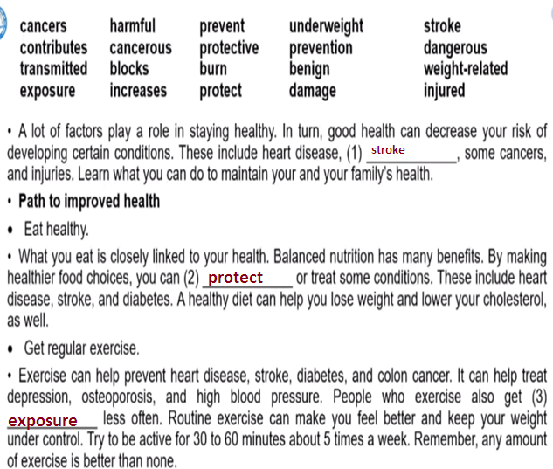

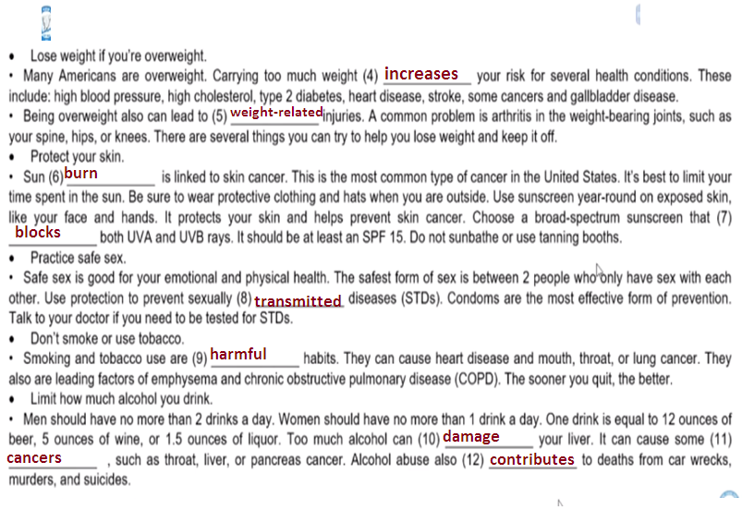

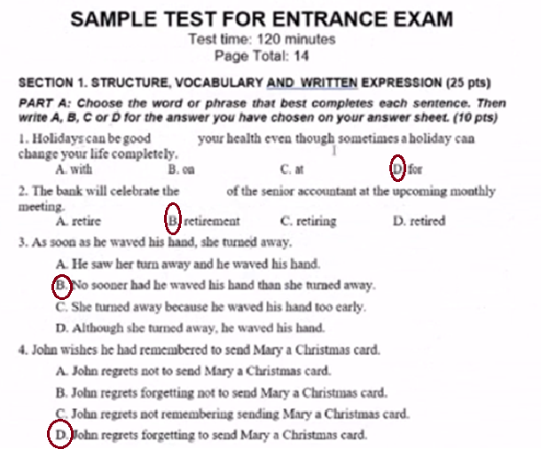

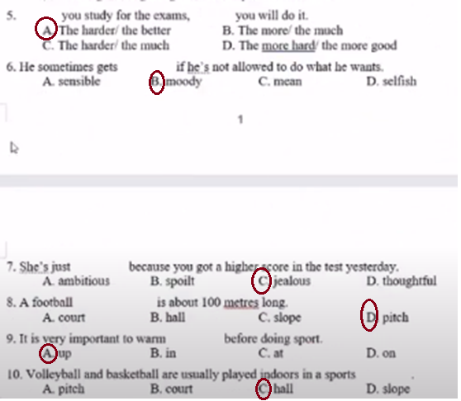

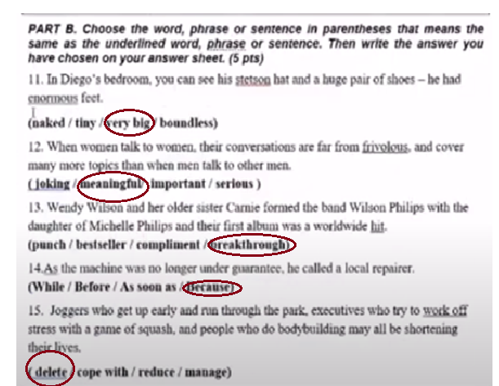

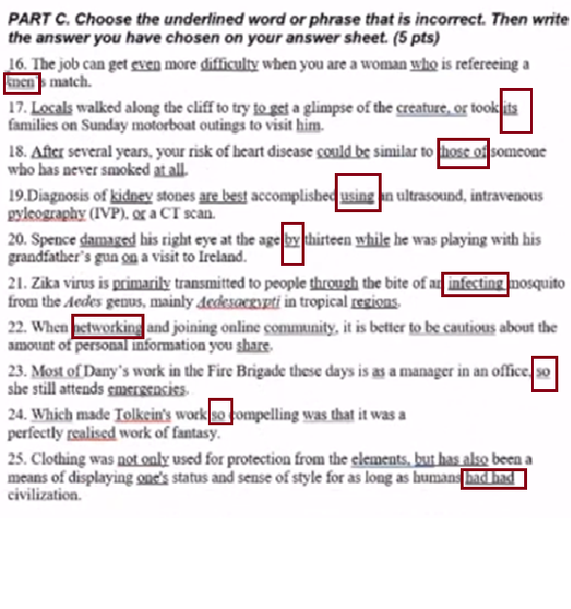

Tìm lỗi sai thôi không sửa lỗi sai

Machine generated alternative text:
sec TON 2. READING COWREHENSION pts) 
PASSAGE (10 pts): Read the to each 
question, A. C, or O 
f.hing village 
Dingle a 
of Daigle it a 
tlxy 
Althcugh dolphin a of 
Thi' dolphi_n iMO 
AS 
days light. dolphin playfully A. 
be 
A' be 
He 
pie. to 
called him of 
in his playmates grew. by 1986. he Was 
nab flipxrs in his with 
He that But 
quwkly a a diver 
his 1K his 
d"er's dim' fimt his 
As felt 
his to play. him 
Fimlly. at in his 
wickly Dingle' cliff to 
try to get a of mniwgs to 
visit him. rts fm 
A'lphin 

Machine generated alternative text:
Dingle, 
of families 
visit him 
risk of missing a might 
As of dolpEin 
vwtus st—d in. 
healed. inspired and v i snot-s alike. 
Kevin El—y of 
1983. He 
Me's 
in aptivity, fm 
18-20 to 
play With uiey 
stays be s in 
of 
dolphins But 
in This is of 
tint a single 
d i a' withül a 

Machine generated alternative text:
TIOy, only Dingle all 
A' of of day vicq•ang 
him "fi 'o tbc with 
No why abk to heal hurt in 
Many 
After 'bys watching 
I all 
in lives. joy, - a grim doe 
why as his 
Dingk thmg this wik' is 240-kilo gift 
thM the to to 

Machine generated alternative text:
26, Diugle 
A, sailed a 
B, do I phuu guy in 'be 
C, gay 
"plain at 
Ibe 
A. tEy 
C at 
dwk i' 
28 his 
A. Fung* off with it 
B. to him 
C let of it. 
D. tried to ex 
29. did have the 
A. He of 
B. Wiry afraid 
C. S— day dry o their dry bun 
D. Tlry 

Machine generated alternative text:
his 
D a big m to fist— 

Machine generated alternative text:
3 Accmd.ng to 
A. pra*ly 'be wiki. 
B, With dolphiw, 
C. will stay in area. 
32. is to 
A. 
33 to 
A, di%bH m•im 
C. impact 
D with of 
word 
S *Titer 
A. or really 
C. the 
D. thms his cm*iviry. 
D. Noac is 

Machine generated alternative text:
PASSAGE pts): 
the and choose the answer to each 
question wnte TRUE, F 
or NOT GIVEN 'or eacn statements 
A . the at 
It makes for worryirw . I S are needs 
child in tlm• . 
- of fruit day have 
ulswer mud vital tutiou•s Recagly. the 
Ods' the I 
to The cost of lettmg 
might of 
ELL It 
early a 
—ge of apple in with 
by finy &inks? 
million yar is exceed 
alking 
ice-cream. 
pmts it to ufveti—ts fm the 
eyes of gnwing at 
dry are at is 50 
of in 
with fæh 

Machine generated alternative text:
No. try pim into Im•ingly 
No. A by (FS Al 
of childRn their 
daily of 'o of 
meals anything 
kitchens by eataing 
With 
which 
diet. 
of same of hig'bfar. 
all 

Machine generated alternative text:
this sized ckRhing . 
'o - of No' 
in ays DI 
of Ifs 
step Ray if IE 
to rplx•e he 
Ray. 
the staff 
*ere go has in - 
and 
wving at a dm•t 
unt"hhy as 
dry with *ate' o 
. is 

Machine generated alternative text:
Rays lathy caning habits with a 
•If a sli« of his plate. 
will di.h will a Been 
put . 'hey 
doins this. SO 
children '"ting for - 2_so and rising 
We a fryer, Which I know 
Inlthy but fr•d fish As well 
to a 

Machine generated alternative text:
'o of 
Tbere S generally less 
diet a eff«t —d. in 
is to dr 
—ts a diet M 
36. of British 
37 a 'Neatly. 
SS to junk 
39 al"" tbm dim 
Abny Ty to —y of the any of the 
I Ray realized his was 
42, The Ray's is 
No in Ray •s 
Rays a of dix 
45. to of cbuges 

Machine generated alternative text:
pts): Read passage and the questions. 
CMV is of or with 
eyWtnegaJcvirus 'CMV b. Ibis sane vim' at 
back of the eye or '"by %hile still in CMV is a 
virus. which is xlated that CMV is very 
_ ample's 
It by 
e of 
or no 
CMV 
'he ATDS 
or 
CMV involving the GI tract «•v-urred a 
CMV 
the 
with 
a,' diffrulty with 
— _ pain. 
bkndy fever, weigh' loss_ More can result in 
or a wall of 
to fight 
for 
nuy A 
CMV gWMlia nuy when dntgs 
drugs fight virus may cause side eff&ts tm side oa 

Machine generated alternative text:
dmg the dn.g a.y wbde 
may i o 
46. Which ty•'r of is 
to wid. CMV to? 
48, What Of 
49 What segue ulcers CMV disease' 
SO. Whal in a s result 

Machine generated alternative text:
SECTION 3. use 120 pts) 
PASSAGE 415 pts): Complete me me given. 
write your 
of by 2020 
is 34 
by 2020. 
dowry of ho C lty•s 
thirds Of with are in stages. 
Swi"ies die fm 
S.m.king is 'o blm• 
in to a joint by 
of u" World 
40.(XH) die of yeu. 
Smok.ng is of Of (53, 
—u the Asian 
'ban dymg diseases day, 
by Halth Ministry slight in in 
Vktx 2010 201 S, fm 23 _g to 22' 
agai IS 

Machine generated alternative text:
Despite declirung Of Vietnam Of 
ol' Smokers 'o the WRId Health 
a Of 93 has IS. 6 
which peop•k. Mid 1 5 years old 
Ibe also ask.' the 
were of it Can on fanuly 
rate 
SO sayutg 
rest—ts_ 62 M 1m at 
lwgely the Viet— to 
to mking 
cmtly up 
of to 
step up efforts by "id Ministe of 
Ngtryen 

Machine generated alternative text:
Read the the i. ms 
pnple tt»t is at—ly 
is easy also 
i' its of guiding (S6'(TOUR) 
'be in City this 
ACIIIEVE) 
wu Oiled Hæy He of 
aM first up with his 
Which tm 
in 1931 —y (S8ucr.EAR) 
a gnes atx•ut 
fu a w%ich slmd 
the This nup 
in 1933. it its (S9XAPPEARb 
platf— a' 

Machine generated alternative text:
'rbe '*sign of ORIGINAL) 
of tighly of Beck's 
by s systems 

Machine generated alternative text:
SECTION 4. WRmNG pts) 
X of the a it 
61. Daisy sn4ying Cty. co is 
62 We are pint 
63 smoke in in England 
we had at. 
SS. to UK 20 years. 

Machine generated alternative text:
R so has a meaning 
Exa*•. A very frientny taxi 'hive. drove town, (DRIVES' 
we my friæny 
66. The English to his class. (BETTER) 
6' We telling ber all (TOLD) 

Machine generated alternative text:
SS. My trkd stay sick. (DESPITE) 
He ber 
I of music (GETS) 

Machine generated alternative text:
SECTION s. TRANSLATION '15 pts) 
pass.s on your "Snr Sheet. 
ptsE 
of di— in xd of 
As of United States mortality. 
utiliution costs. high of 
ob:sity 'O Strain Stares systan. 
Cb:sity 
B'*fy I BMI' 
(xe A fat is an cell is an As 
a Of 
—g Siuifrmtly. 
fatty Ibis Can 'o 
in lad to 2 
is High wah 
high defic—y. Water 
of dim 

Machine generated alternative text:
—y into Ff"ly. first 
diff— '—plc 
of is to is kming a —d 
A tntive will easier to tbaa 
of Ch—. simiiu *wish. 
While is first a 
gmter tbe the will 
fcw peopk to is the 
inn—d by of tbe Miring 
Chine* 'o Very many 
Japx in 
will of 

Machine generated alternative text:
to *hile 
tv is play role. as 
'try 
to it ary often learn it a 
direct day life. No 's easy 
which are to first a 
writing SYStezn is a Challenge. that nuke a 
tie "L it inw"ible to "y 
is diffKu1t in 
THE END 